# How to send a tweet

This recipe shows you how to send a tweet using iOS5’s Twitter integration.

**Sample Code:**

**Related Articles:**

[related Xamarin articles list]

**Related Apple Documentation:**

[TWTweetSheetViewController Class Reference](https://developer.apple.com/library/ios/#documentation/Twitter/Reference/TWTweetSheetViewControllerClassRef/Reference/Reference.html)

## Recipe

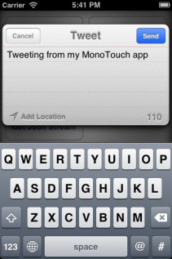

To help the user send a Tweet using MonoTouch.Twitter:

1. First check if they have the capability to Tweet:

if (TWTweetComposeViewController.CanSendTweet) {

// Add code below

} else {

// Show a message: Twitter may not be configured in Settings

}

1. Create a TWTweetComposeViewController with the suggested text for the tweet (the user will be able to edit this):

var tweet = new TWTweetComposeViewController();

tweet.SetInitialText ("Tweeting from my MonoTouch app");

1. Add a handler that is called after the user has either sent or cancelled the tweet.

tweet.SetCompletionHandler((TWTweetComposeViewControllerResult r) =>{

DismissModalViewControllerAnimated(true); // hides the tweet

if (r == TWTweetComposeViewControllerResult.Cancelled) {

// user cancelled the tweet

} else {

// user sent the tweet (they may have edited it first)

}

});

1. Display the tweet so the user can view, edit and send or cancel.

PresentModalViewController(tweet, true);

## Additional Information

Before a tweet can be sent from within an app, the user must configure their Twitter account in Settings.

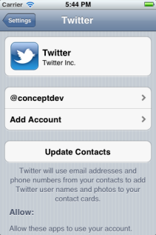

To add a link to a tweet, call AddUrl:

tweet.AddUrl (new USUrl("http://xamarin.com"));

To add an image to a tweet, call AddImage:

tweet.SetInitialText (UIImage.FromFile("some_image.png"));